# FIRST WEEK CHALLENGE

# SHAOYUAN WANG

This week was totally challenge for me. I couldn’t understand much at Shaon’s class at the first day. But I gradually found out how to work on Arduino Board with Jon, Martin and classmates help. We kept learning, sharing and help each other, which makes me feel like I am at home - HUBMO.

Home can be not only the one with family members but also the one with friends or even strangers. We tried to make definitions of HOME based on our personal understanding. It could be mother’s cooking, the place to be messy, being with pets and so on. This made us expend our understandings about home. We started brain-storm about the things connected to home as two groups, one is with family members, another one is with non family members like flatmates. Apart from the products or appliances are different between different types of home, the attitudes and behaviors are also different. We analysed what kind home can it be, what kind of tenants can they be, what conflict can happen, what things can they share. This phase helps us to have more ideas on the things related to home in various aspects.

After showing us a video about the things in universe. I was surprised that the scale of universe was unexpected enormous. We also tried to seek the smallest and biggest thing at home in the same way. The result was quite impressive. The smallest thing can be dust or breath, on the other hand, the biggest thing can be wall or even smell and other perceptions. We had much fun to compare the size of each thing. This method helps us to catch the points which we usually ignore as well as expend thinking.

We aim to make ideas based on Arduino board software and hardware. We tried making simple prototypes with different lights and sensors. I was attracted by the tonemelody from buzzer. My first idea is a plant trim reminder which is inspired by Jon’s ‘Shave and hair cut, two bits’. I was thinking it would be amusing to ask for a ‘shave and hair cut’ from plants, which makes an interaction between owners and plants. Design can solve problems, also, it can make interaction happen.

We made effort on dealing with programming and connecting parts on Arduino boards. Sometimes I become impatient when I have difficulties. However, once I made LED or buzz or sensor work I would be full of sense of achievement. People always feel more exciting when they succeed after struggling a lot. I also had fun to test different effects. Jon asked Mia try to blow temperature sensor then something magical happened. It might happened by accident, nevertheless, some unexpected and beautiful result come after random try.

My ideas are inspired from daily life. For example, one of my ideas is digital coaster. The lights coaster will fade if your friend’s cup is empty or with little tea when you are having chat together. In Chinese culture, we will feel impolite or embarrassed if we ask for more tea or drinks at other’s place. So I think maybe the coasters can tell host, the host can also show their hospitality. I feel these tiny movements are important in our lives; sometimes they can change people’s perspectives; sometimes they can change people’s attitudes; sometimes they can change people’s habits.

For next stage, I am going to develop my ideas, keep doing experiments on Arduino board and making prototypes to make my design more reasonable and understandable.

# FIRST WEEK CHALLENGE

# SHAOYUAN WANG

After intense Arduino study last week, this week we focus more on our ideas. I developed my idea of digital coaster at first but it is not understandable idea because of the difference between Chinese and British culture. So I was looking for better problem afterwards. Occasionally, I had new idea after meeting with friends. They inspired me. The idea is about social exercise. My friends don’t have much time to go to gym because of heavy desk-work. So usually they are not able to go to bed until late night. Therefore, their back and shoulders are quite stiff. At the same time, they are getting more fat since they spend most of time on chair. And another reason of lack of exercise is laziness. It is difficult to have motivation to do some sports if they are alone.

However, we stretch a bit together and try to do yoga or indoor sports together when we gathered at someone’s flat. This scenario enlightened me to make product for friends to enjoy doing exercise. After that, I found that one of factors of doing sports with more passion is working out in group. Group exercise can happen among family members or friends with nice interaction for fitness.

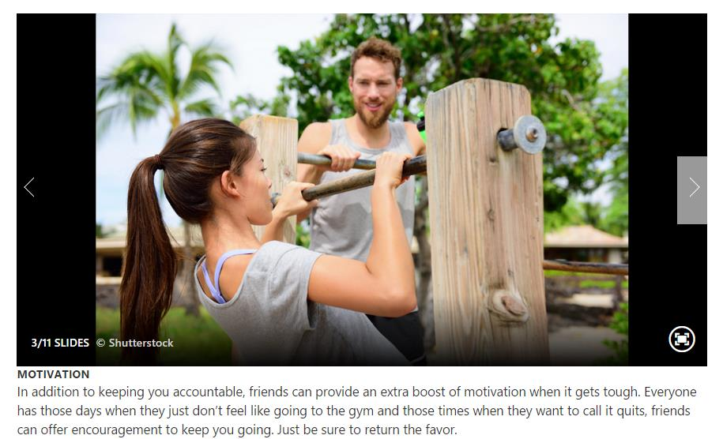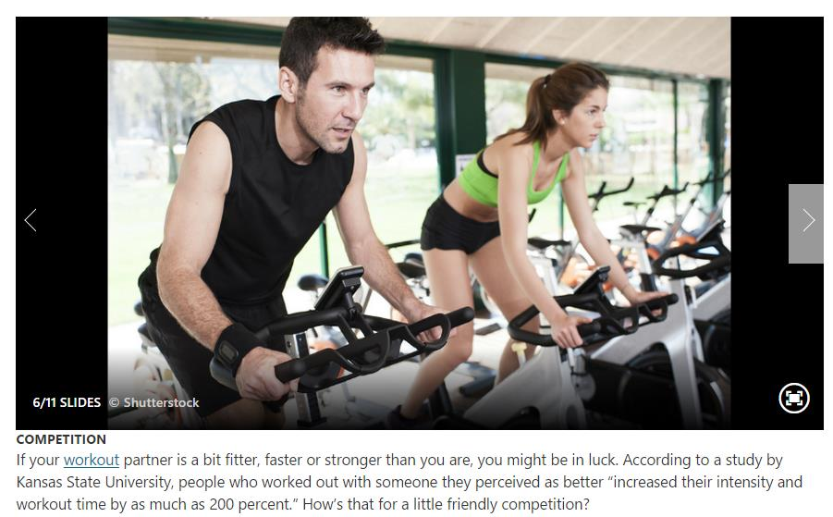

Working out with friends is better than exercising alone, researchers say. A study of 1,000 women found that 64 per cent of those who run, go to the gym or attend group exercise classes with chums will push themselves harder than if they went alone. Those who exercise together train for longer, burn more calories and go to the gym more often.

The target suppose to be the people don’t do much exercise or work a lot at desk. For them, I searched some light indoor exercise online which can relax their muscle. Twisting waist on spin chair is suitable for them because it is easy and not strenuous.

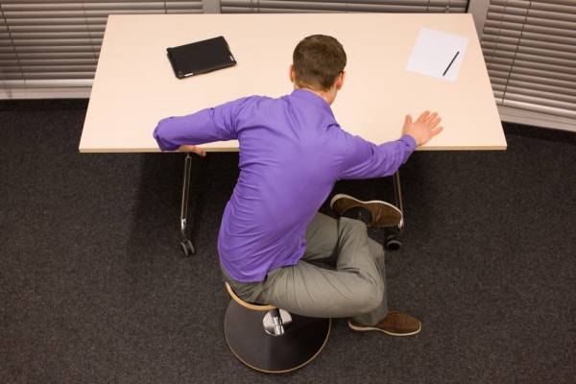

My original idea was that the lamp will be turned off on time (10:30p.m) to tell you to take a break potentially, then the LED light will be on to invite you to join to do exercise together when the members start twisting their waists. But this is a little complicated as a product design. I should focus on one aspect instead of linking many different things. Sometimes it is easier to make concept not strong enough or too complex when I have many thoughts of possible function. After the advice from Fraser and Martin, I amended my idea, which focus on the method of encouraging members to do exercise together(at the same time).

I started looking at the portable equipment - dumbbell.

The main merits of dumbbell:

1. Portable, doesn’t need much space
2. Balance body and muscle
3. Safer
4. Good for shoulders, back
5. The place doesn’t matter

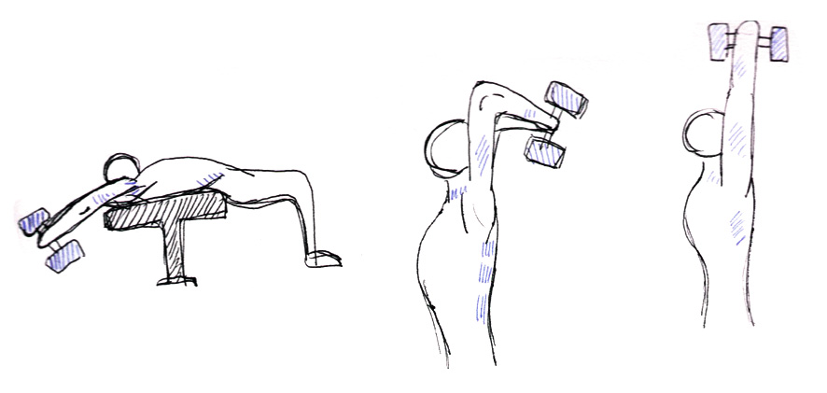

The current idea is Digital Dumbbell.

The dumbbells are connected, so the lights of dumbbells will be aromatically on when people start doing exercise. It invites your friends or the people you are linked to do exercise together. More people join more lights blink.

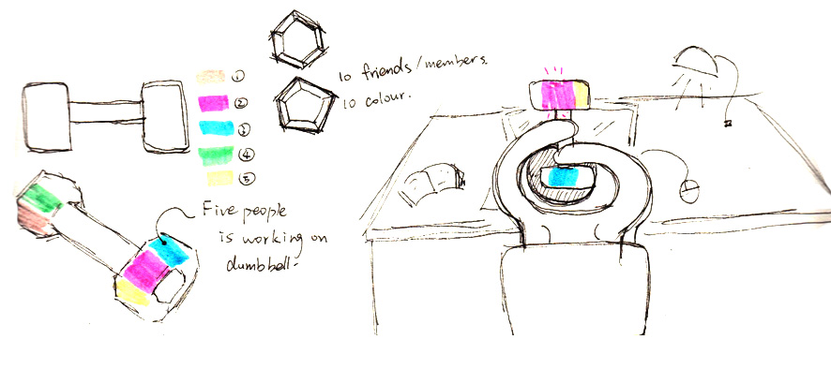

For next week, I would like to figure out the technology part to support my concept.

# THIRD WEEK CHALLENGE

# SHAOYUAN WANG

For this week I kept developing ideas. On Tuesday, I had Skype tutorial with Jon, he expended my thoughts. My idea was social dumbbells which encourage people do exercise together. But exercise can be different style, not just using dumbbells or other gym equipment, like doing housework, cycling, cooking and so on. So the exercise can be regarded as some movements which are possible to be low strength or high strength for people in different ages.

Sharing the movements with others is positive and interesting interaction for the members who have some distance from each other. I also talked with the friends who are into sports and activities. Most of them told me that they prefer to do sport with friends. And they are also curious about what activities are their friends doing.

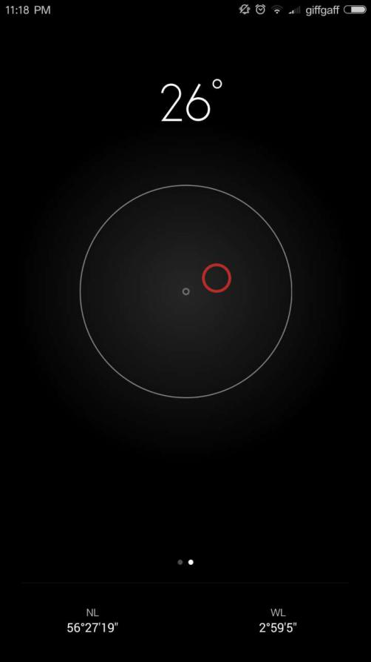That would be fun to know what movements your family members and friends are doing, even can be your pet like cat and dog. So I was thinking about sharing daily activities by visualizing behaviors. There were a few methods to visualize movements after my research. One of them is the function on the phone which tells the horizontal angle with moving circle.

However, considering about time wise, I chose tilt switches connected Arduino boards. But for sensitivity, I would like to find out better devices to support the concept in the future. Each LED lights will be connected with one tilt switch, then it works as the application on smart phone basically. It is designed as an portable attachment which can be attached on our body or animal’s or the products we are using. It is also available to carry in pocket to everywhere. The holders could be linked through internet so that people can monitor their partner’s activities. The product is possible to be in different use, for elderly and children, we can check safety; for pets, we can see how crazy they can be at home; for friends, it decrease their psychological distance.

I enjoyed the process when I develop my ideas. I can see how does my concept grow from the first one. And the story help me to think the problem and solution. I created various scenarios in different locations like home, park, office as well as with people in different positions or ages. The same product might occur different effects so it is playful to see people use it in different ways. Additionally, I expect my product to bring people together - Light Orchestra.

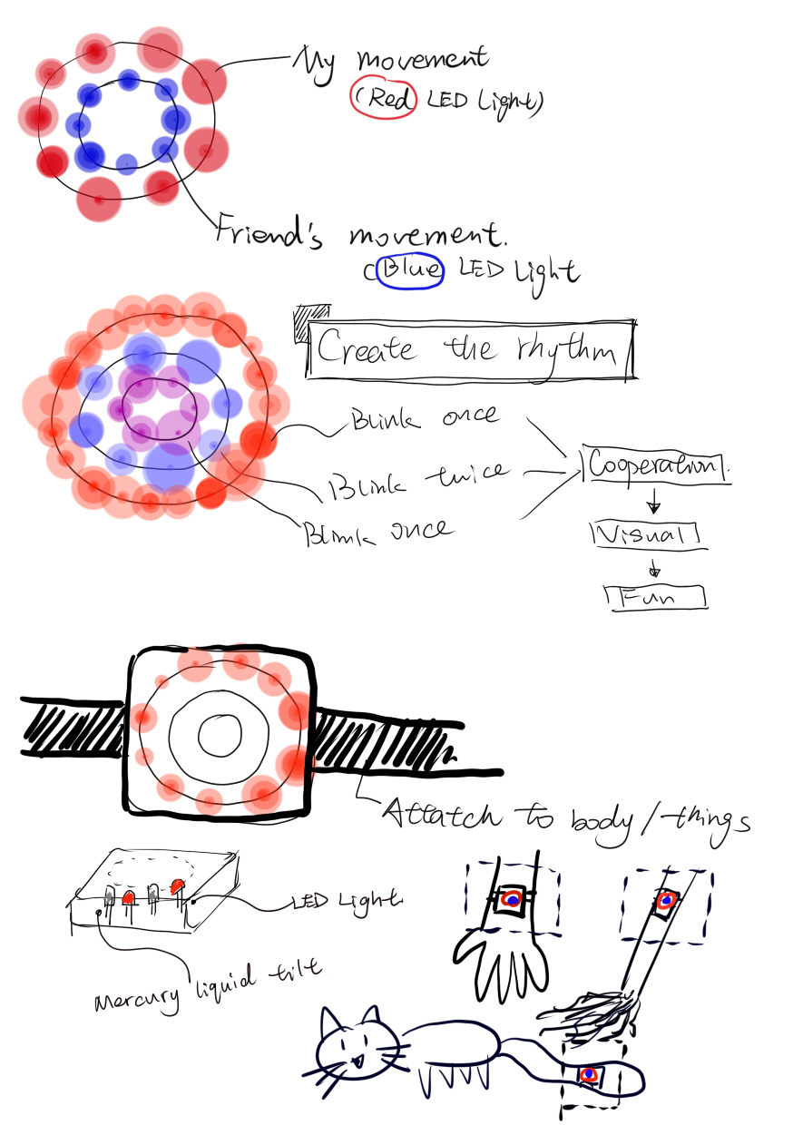

For the repetitive movements, it seems to make its own rhythm like drumming. I use the LED lights to present the behaviors. If members work at the same time, the light will blink simultaneously. After that, users can workout together to create their own light performance. I would like to say it is a movement game.

Next week, I should focus more on prototype to explain my concept. Material, structure, shape need to be concerned.

# FOURTH WEEK CHALLENGE

# SHAOYUAN WANG

This week is the final week. We were all busy with making prototypes and videos. The shape of my prototype is a wristband which is hard to put whole electronic part - Arduino board inside. I soldered wires together to make it more flexible to connect to the attachment. I tried a few ways to connect Arduino board to it, but it looked still not ideal. However, Jon and Martin suggested us to put more emphasis on concept instead of struggling with appearance too much.

On Wednesday, I started taking videos for the product. Since it is not perfect shaped so I tried to take loads of pictures for one fluent behavior instead of taking film. I found out the way to present my idea could be various. I also would like to learn more about editing video. I haven’t done any video editing before so I studied how to edit video from zero this week. At first, I wasn’t with much confidence , but after I get know more about operating the program-Premier I began getting into it. I enjoyed trying many video effects and playing with audio tracks. I cannot say my video is professional or perfect but I enjoying the process when I did lots of experiments to see different result. As well as like I adjusted the angle of tilt switches, I could not fold them in perfect accurate angle. But when I saw the tiny differences of light effects I got to know which angle was correct and which was wrong. That was the most enjoyable part for Arduino experience. Honestly, if I just struggle with editing code alone I would just keep confused and even annoyed. Every time I made a little change for the effect then I felt I succeeded even though it was only tiny achievement.

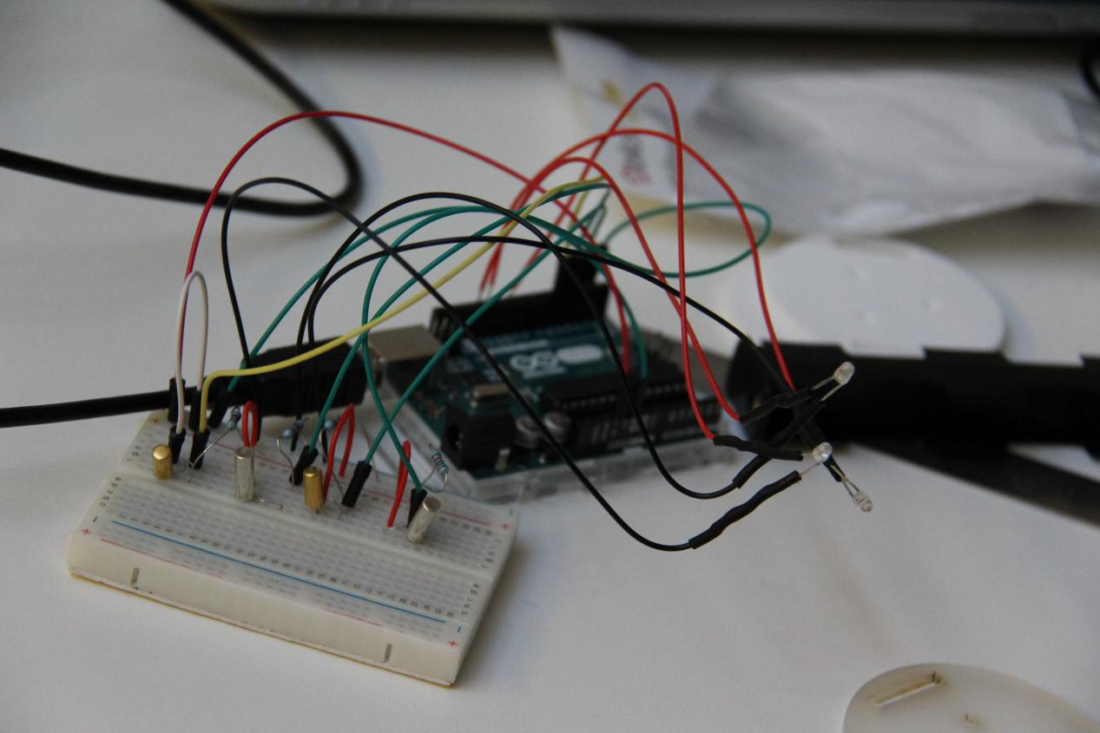

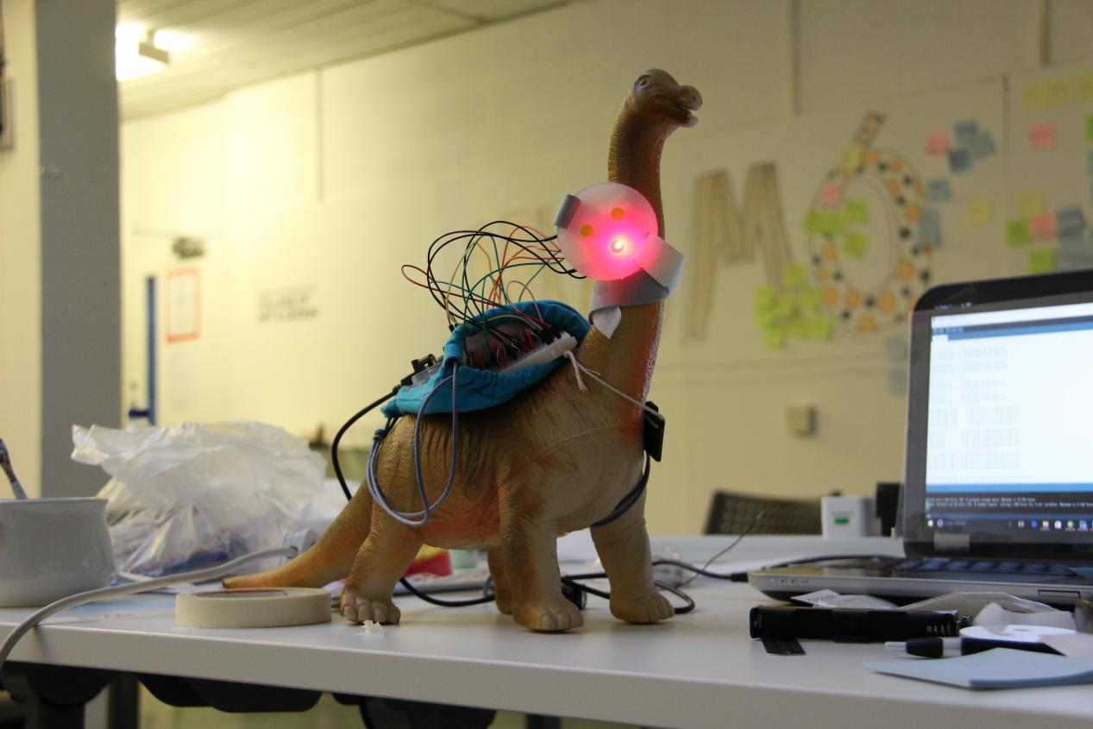

During these four weeks, I learned new skills and design design thinking. What’s more, I totally felt the difficulty in this course since I came from different major, different country, different culture. I wish I could have more time to try out my product with different users to develop my concept.